HEY YOU!



Finals can be stressful, especially when you have a 10 page paper due in a few days about a survey you haven’t finished yet. Hence, if you have some kindness in your soul, I implore you to take this 2 minute survey about what social media you use the most and to spread a picture of this poster so that I can finish this survey before the end of the week.

Survey:

(and URL in case you can’t read QR codes):

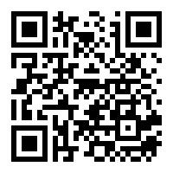<https://forms.gle/Mf5vWwyBcrHxYuiL8>

Thanks